### Version Control Software Evaluation

**Version Control Software Evaluation Report**

**Math for Games**

**Ryan Jones**

**06/04/21**

**Version Control Software:**

The version control software used was: GitHub.

The client program used was: GitKraken.

**Performance:**

The GitKraken software was nice to use allowing me to integrate it into my routine easily, the interface seemed intuitive with tabs to allow me to switch between projects quickly and only 2 buttons to confirm my updates, and a text box where I can enter a short description of what the changes I am making are.

My main gripe with GitKraken is having to log into my account every time I want to push my project to GitHub, this is made up for with the fact that all current projects are loaded automatically before login is required, allowing me to view past changes quicker.

With the small scale of my tank program with only one programmer GitHub/GitKraken was extremely easy to use and I would recommend it for version control for any small projects you may create, this may not transfer to larger group projects though.

**Evaluation:**

This software is useful for keeping your projects safe and is useful in a team environment as you can share and branch projects as a team.

Group projects using this software could be clunky to use together without coordination though this is only speculation as I have not used the software in a group before.

**Environmental Considerations:**

When considering using GitHub it should be known that it runs on servers from a warehouse which may leaving an impact on our carbon footprint

On free GitHub accounts actions and file sizes are limited using private repositories so larger projects could have an issue unless made open source.

If GitHub were to be used in a larger scale industry project, the cost of $21 per month should be considered.

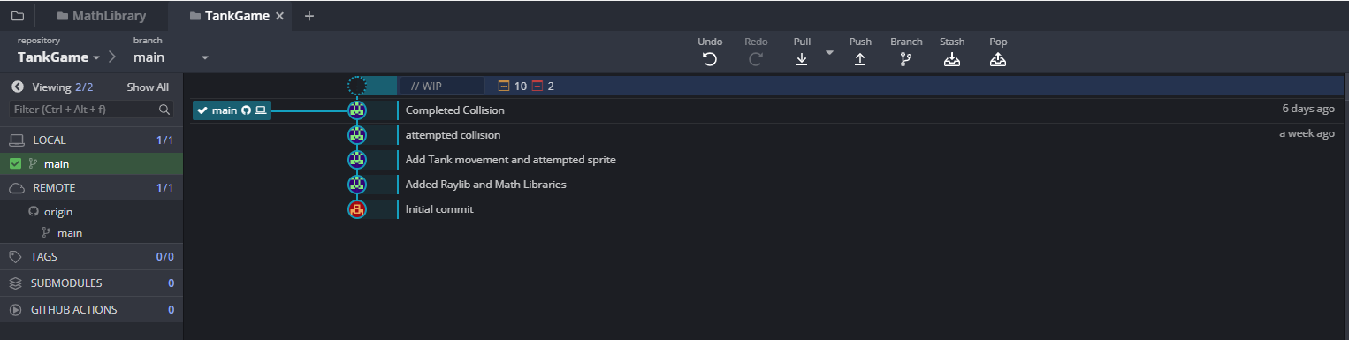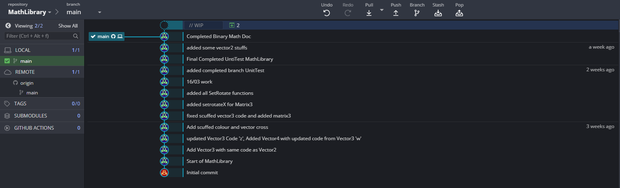Screenshots of Version Control